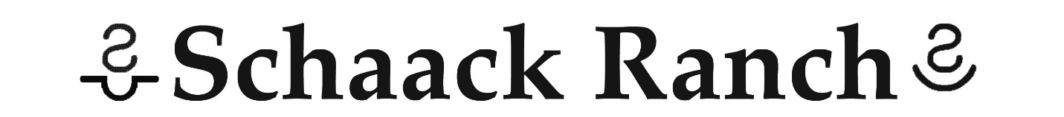
23650 Sage Creek Rd
Wall, SD 57790
605-279-2869 home chschaack@gwtc.net
605-685-3311 Clays cell www.schaackranch.com

Stallion breeding contract for jess vegas
This STALLION BREEDING CONTRACT is by Schaack Ranch (authorized agent) and between MARE
OWNER ___________________________________ for the breeding season of 20_____ is made and
entered into on this ______________day of ________________, 20_______. Mare owner agrees to
breed the mare ______________________________, reg number ___________________ to JESS VEGAS for the fee of $2000.00 for a live foal subject to following conditions:
- The stallion fee includes a nonrefundable booking fee of $250 payable with this contract, the balance of which must be paid before semen is shipped or collected.
- A) Stallion will be housed at Schaack Ranch.
B) All breeding services and fees: either cooled semen or reproductive services, or mare care is through Schaack Ranch.
3. Multiple embryo transfer if more than one embryo is produced from stallion breeding under this agreement and if multiple embryos are transferred, then mare owner must notify stallion owner within 48 hours of transfer of embryo(s). If embryo transfer results in multiple pregnancies, then mare owner must pay stallion owner for each pregnancy.
4. This contract contains a (live foal guarantee). A live foal is described as a new born foal which stands and nurses without assistance. If a foal is born dead there are return privileges for the next breeding season only if breeder is notified within 30 days and receives a veterinarian’s statement of death. If after pronounced “safe in foal”, the mare should miscarry, abort, or prove barren after leaving the breeders premises, the mare owner as the privilege to return her for breeding during the current breeding season or the following year. Mare owner may not assign this breeding contract or substitute any other mare for the mare under this agreement, without the prior consent of stallion owner. Any attempted assignment without the prior consent of stallion owner will, at the option of the stallion owner, terminate this agreement and release stallion owner from all obligations hereunder.
5. Normal breeding season February 1 to July 1.
6. A breeders certificate will be issued for the foal, conceived by this mating when the mare has produced a live foal by this mating.
7. If Stallion dies or becomes unfit for breeding in the opinion of stallion owner, this agreement at the option of stallion owner, immediately terminate on behalf of mare owner. The stallion service fee (less booking fee) will be refunded and the stallion owner and mare owner will be released from any further obligations under this agreement. If the stallion is sold, the new stallion owner will honor rebreeds for one year from the date of breeding. No refunds will be issued if stallion is sold.
8. This agreement contains the entire agreement between the parties and maybe amended in writing signed by each of the parties. South Dakota Law governs this agreement.

STALLION OWNER MARE OWNER
Schaack Ranch (Clay and Holly Schaack) X______________________________________
Leon and Amber Garrett signature of mare owner, or authorized agent
Authorized Agent: Clay or Holly Schaack _______________________________________
By:_________________________________ printed name of mare owner
Address:________________________________
________________________________
Home telephone _________________________
Cell phone ______________________________

